Last Updated 4/3/20

Connecting to the Internet

I just received a Cellular Enabled/Internet Enabled iPad from NYCDOE. What does Cellular Enabled/Internet Enabled mean?
The iPad you have received is a cellular enabled device that is able to connect to the internet without the use of a hotspot or WIFI connection. The iPad is able to connect to the internet through a unlimited cellular plan provided by T-Mobile at no cost to you.

How do I know if cellular data is turned on for my iPad?
You will be able to connect to the internet, use Safari and Chrome web browsers. If you cannot access the internet, go to Settings> Cellular Data> Switch on Cellular Data>Tap Cellular Data Options> verify that Enable LTE is turned on.

How do I know whether the iPad has successfully connected to the internet?
If the WiFi icon appears at the top of the screen, the iPad is connected to a Wi-Fi network. (To verify this, open a web browser like Chrome to view a webpage.) iPad reconnects when you return to the same location.

Security

Does this tablet keep my child from going to certain websites?
Yes, T-Mobile’s Education program comes with built in filtering. This is a service that prevents access to adult content and follows the Children’s Internet Protection Act (CIPA).

Am I able to add my personal Apple ID?
No. This iPad is for school work, not for personal information..

Am I able to add new applications to this iPad?
No. All applications are put on and taken off of the iPad by NYCDOE.

Signing in to DOE Accounts

How can I find my child’s Student Account ID and Password?
- Go to Student Account Self Service
- Enter your 9-digit Student ID (OSIS) number. (You can find your Student ID number on a report card, your student ID card, or in your NYCSA account.)
- Enter student birthday.
- Click Continue.
- If the information you enter is the same as your student record, your username will be displayed.
- Your student ID is your username followed by @nycstudents.net.
For example, if your username is JaneD, your student account ID is JaneD@nycstudents.net.
- If you haven’t already set up a password, you will be asked to set one up.
- Pick a password that only you will know.
- Re-enter your password.
- Click Update Password. How does my child get started in Google Classroom?

How does my child get started in Google Classroom?
- Open Safari or Chrome and go to the Remote Learning Portal: https://idp.nycenet.edu/
- Enter your DOE student account email (it ends in @nycstudents.net)
- If you don’t know your DOE student account email, visit DOE Student Accounts
- Enter your password.
- Click Sign In.
- If the username and password entered are correct, you will be signed into the remote learning portal successfully.
- Click on the Google Classroom icon.
- Now you are in Google Classroom! Here you will find instructions on how to get started using

How does my child get started in Microsoft Teams?
- Go to the Remote Learning Portal: https://idp.nycenet.edu/
- Enter your DOE student account email (it ends in @nycstudents.net)
- If you don’t know your DOE student account email, visit DOE Student Accounts
- Enter your password.
- Click Sign In.
- If the username and password entered are correct, you will be signed into the remote learning portal successfully.
- Click on the Teams icon.
- Now you are in Teams!

What if I still need help with my account and logging in to the iPad?
- If you are unable to access your child’s student account, contact your child’s school. They can provide you with your student’s account ID and password.

Applications

Which applications are currently on the iPad?
As of April 1, the following apps are on each iPad:
- Office 365 Apps (Teams, Excel, Word, PowerPoint, One Drive, One Note)
- Google Apps (Classroom, Sheets, Slides, Drive, Gmail, Hangouts, Translate, Chrome)
- LIbrary Apps (SimpleE, Queens Library)
- Security Apps (Cisco Security/Connector Umbrella, Crowdstrike)
- Other (Flipgrid, Adobe Reader, RB Digital, Overdrive, Axis 360, Freegal)

How can I have a new app added to the iPad?
Have your child’s school representative (Principal, Teacher or Service Provider) send a request to remotelearning@schools.nyc.gov (put “iPad App” in the subject to request an education related app.

How do apps get updated on the iPad?
The iPad has the latest version of the iOS operating system and apps. NYCDOE will check if any updates are needed.

How can I switch between the @nycstudents.net account and a school specific G Suite domain account in Google Classroom so my child can access school assignments resources from both domains?

Step 1 - Click on the Google Classroom app

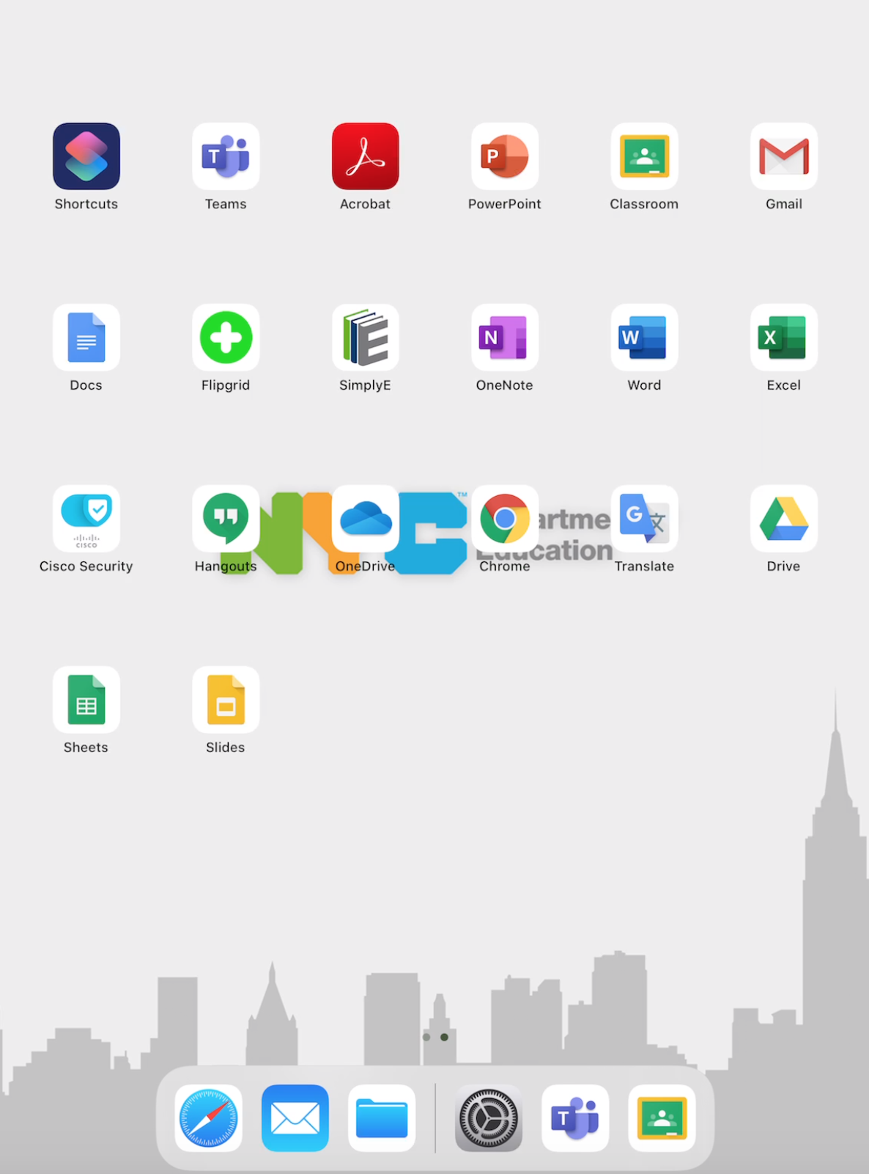

Step 2 - Sign into Google Classroom using your child’s @nycstudents.net account or their school’s G Suite Domain account.
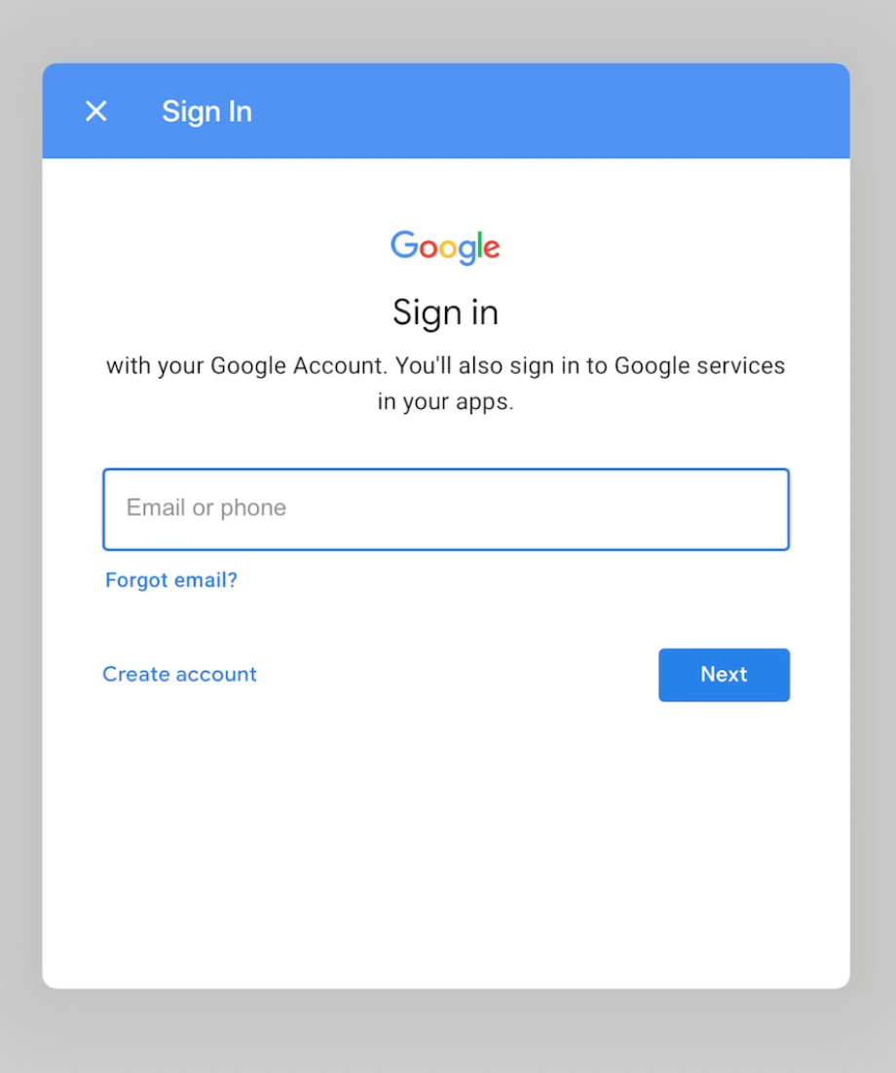

Step 3 - If using the @nycstudents.net account first, sign in again using your child’s @nycstudents.net account username and password to the NYCDOE verification portal.
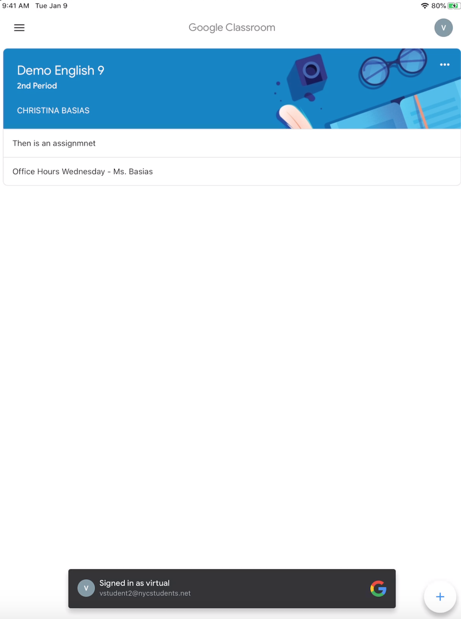

Step 4 - Once successfully logged into Google Classroom, on the upper right there is a colored circle with the first letter of your child’s name; click on that circle.
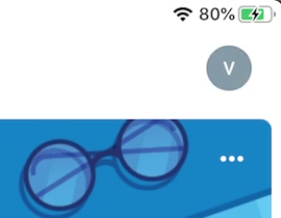

Step 5 - To add a second account (child’s school domain account), log in following the steps above.

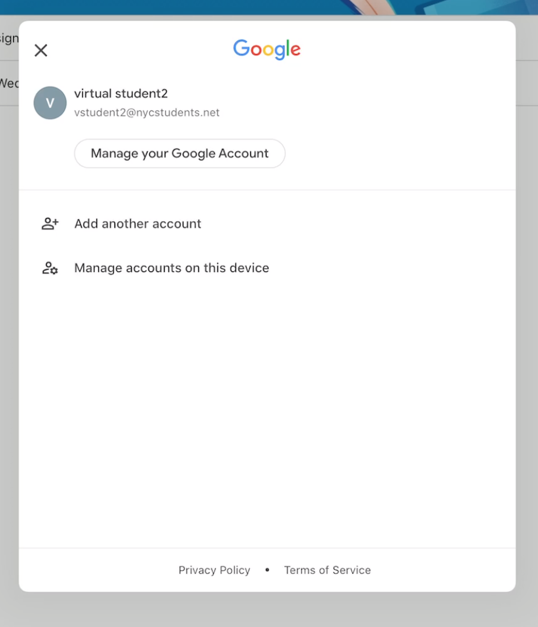

Support

What if I need help or have more questions about my iPad?
- If you need help on how to use the iPad, contact Apple support at https://support.apple.com or call 1-800-800-2775, option 3 or,
- If you need to contact T-Mobile, please visit https://www.t-mobile.com/support, or call 1-800-375-1126 to talk to an Expert. You may experience longer than usual hold times, but we will assist you as soon as we can. When you are connected with T-Mobile, please tell them that you are part of the New York City Department of Education Rapid Response Program.
  - For a faster resolution, please have the ICCID for your device available to share with your T-Mobile Expert. You can find this on your iPad by navigating to Settings > General > About > ICCID

What does Apple technical support include?
- 24/7 priority access to Apple experts via chat or phone
- Dedicated support available at 1-800-800-2775, option 3
- Using iPadOS and iCloud
- Questions about Apple-branded iPad apps
- Connecting to wireless networks

What’s the hardware coverage on the device?
- AppleCare+ for Schools provides 2-year, 3-year, or 4-year hardware coverage for iPad and Apple Pencil and includes the following: iPad, battery, Apple Pencil, up to two damage incidents per year. Service options include: Mail-in repair, Carry-in repair, Express Replacement Service

Apple Support Apple Care+ for Schools
iPad: For hardware and software support, call AppleCare Support for the NYCDOE at phone 1(800)919-2775, PIN 692363 (NYCDOE). To request a repair, send an email to AppleCare at acnycdoe@group.apple.com. Please include the device’s serial number and a brief description of the issue.

District 75 iPad repair Bundle Send an email to D75ATRepair-Replacem@schools.nyc.gov. Please include the iPad’s serial number and a brief description of the and issue.

